**BIO DATA**

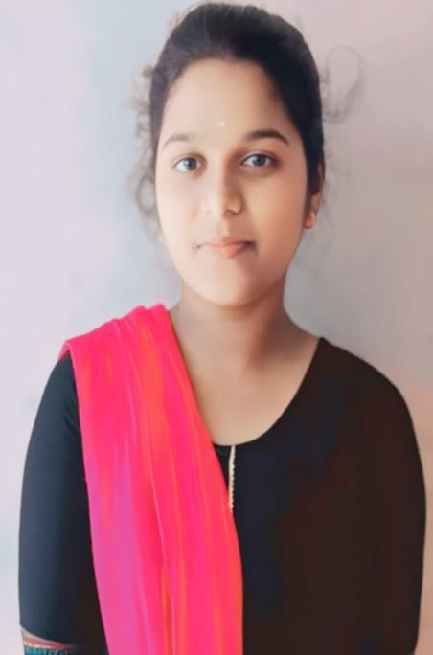

Name : K.RITHIKA

Father's name :N.KUMAR

Mobile :9361184754

Email ID : rithikak4312@gmail.com

Gender : FEMALE

D.O.B. :20.02.2005

Martial status : SINGLE

Nationality : INDIAN

Languages know :TAMIL, ENGLISH

Education :

| Examination | University/College | Year of passed |
| --- | --- | --- |
| 10th | Government Girls higher secondary school | 2021 |
| 12th | Government Girls Higher secondary school | 2023 |
| UG | Queen Mary's College | 2026 |

Computer Knowledge :DATASTRUCTURE,C,

PYTHON

Experience : FRESHER

Address : No.110,

MUKKANIYAMMAN

KOVIL STREET

THIRISULAM

DECLARATION : I assure you that all of my information given above is true

Signature